**Exercise for Introduction to Databases**

1. **Create Database**

Ans :

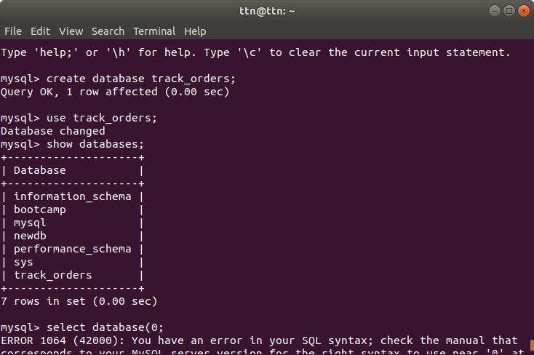

1. **Design Schema**

Ans : E-R Diagram :

Customer primary key : cust_id

Salesperson primary key : salep_id

Orders composite key : order_id+cust_id+salep_id 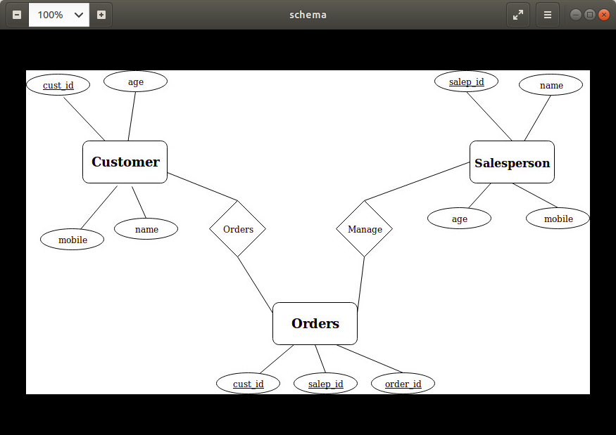

1. **Create tables**

Ans : 3 tables are created “customer”, “salesperson” and “orders”. 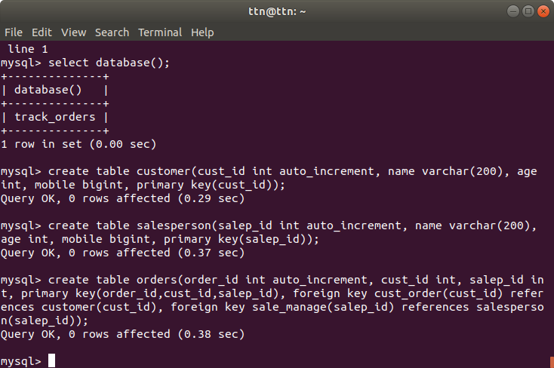

1. **Insert sample data**

Ans : sample date for customer table :

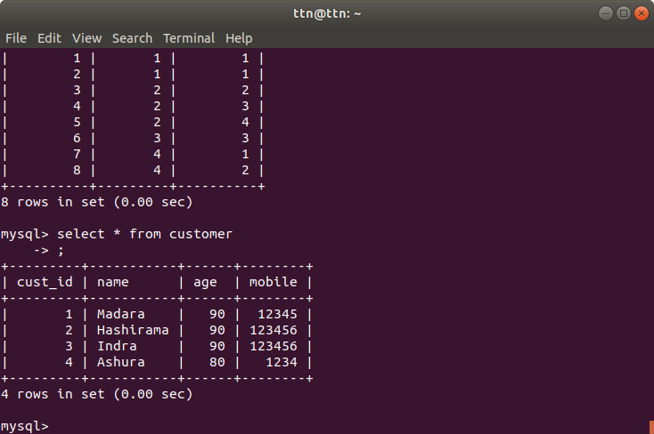

Sample data for salesperson table :

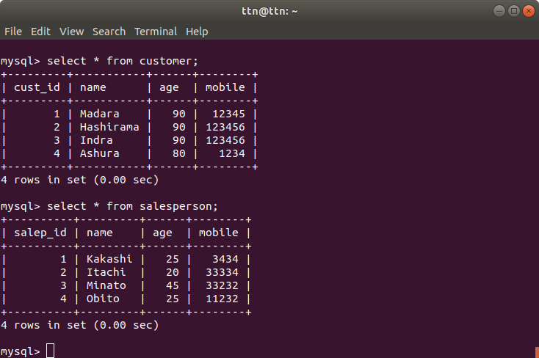

Sample data for orders table:

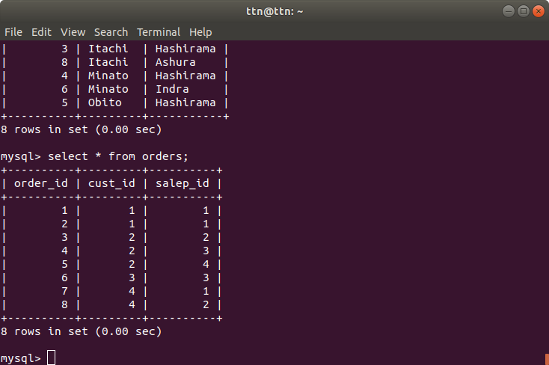

1. **Find the sales person have multiple orders.**

Ans : I have used nested queries here. Firstly, the innermost query fetches all those sales person ids that manage more than one order(i.e ids are 1,2 and 3 not 4.There are four salespersons in sample data). This nested query returns multiple rows to outer query and outer query compares its own data to returned result using IN operator, and prints data that are same.

Data in orders table. Salesperson’s id(salep_id) are shown along with their order ids they manage. Salep_ids 1 ,2 and 3 have multiple orders. Only id 4 has just one order.



Here, except id 4, all salep_id are given as output because they have order count of more than 1.

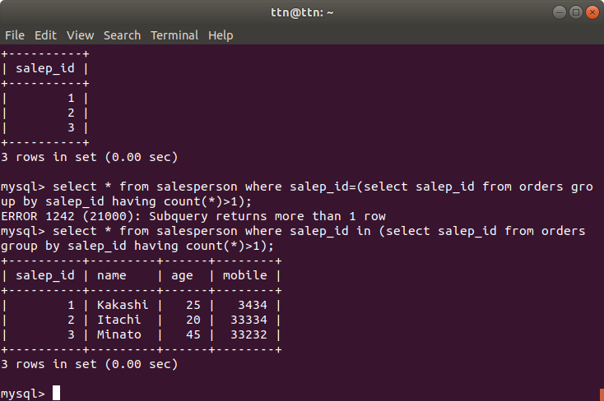

1. **Find the all sales person details along with order details**

Ans : Left join query used here. Details of all the sales persons along with all their orders have been printed. Left join returns all the data from left table and common data from right table.

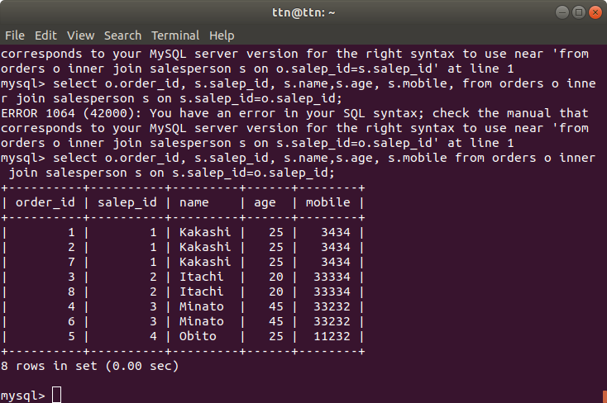

1. **Create index**

Ans : Indexes are used to put a data structure on an attribute in a table. It is done to make fetching of data faster, compromising insert and updation speed of that attribute.

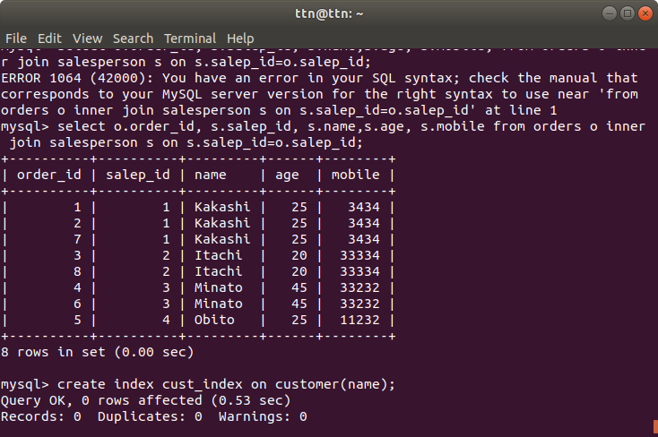

1. **How to show index on a table**

Ans : B tree inserted on customer name.

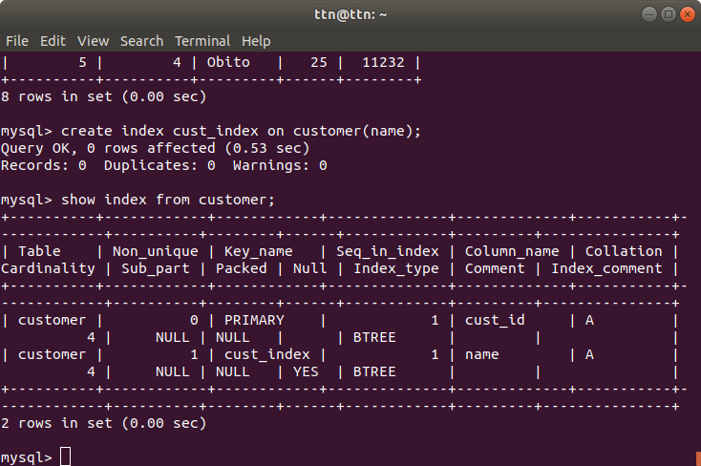

1. **Find the order number, sale person name, along with the customer to whom that order belongs to**

Ans : Left join query has been used to fetch data from 3 tables that share some common attribute.

